**How to revert back project folder which we have deleted**

The below procedure will work when you delete the project folder with commit message.

**How problem occurred:**

User was requested to update the new name to the existing project folder inside the Projects.ETO project

What I did is,

* I have checked out the particular project folder from the 01_Projects
* I have just renamed the project folder and
* I have added and committed
* After committing I have done SVN update after updating I was able to see two folders with old name and new name so what I did is I have deleted the old folder name and I have committed
* But repository which I have updated new name it didn’t work properly it means the instructions which I have followed was not correct

Finally we lost the actual repository from the server.

**How I have reverted it back (Original project folder)**

**By following the below steps I have taken backup of the old repository,**

* I have checked out 01_Projects somewhere
* I have gone through the logs and I have searched for the log message which I have given when I deleted the repository
* I have given right click on the deleted log message and I got one option that **revert changes from this revision** I just clicked on that so all the changes reverted to the local machine after that I just committed project folder
* I logged on to the server and I have refreshed it and i have checked whether I am able to see deleted project folder or not but I am able to see and issue got resolved

**Please refer below screen shots for revert back deleted project folder,**

I am taking one example here which I have tested in DMS Q machine,

Step1: Checkout the 01_Projects of repository ( checking out complete 01_projects will take much time so just checkout 01_projects url and cancel it then you can see all the logs )

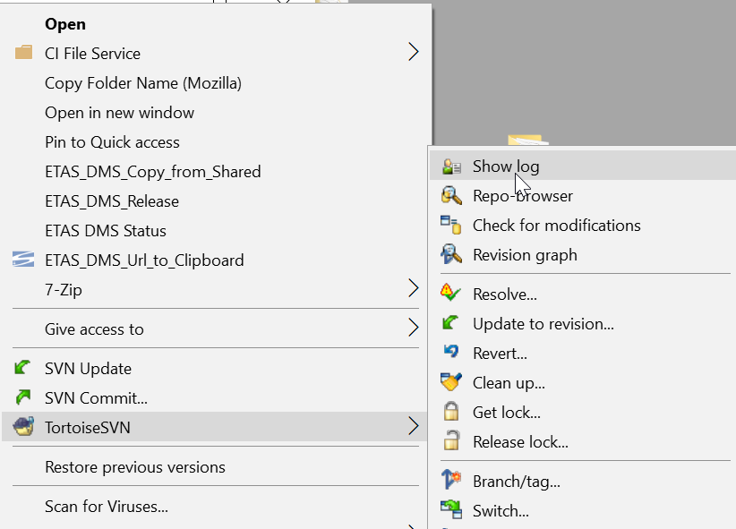

Step2: Go to the SVN logs and search for the log which you have deleted

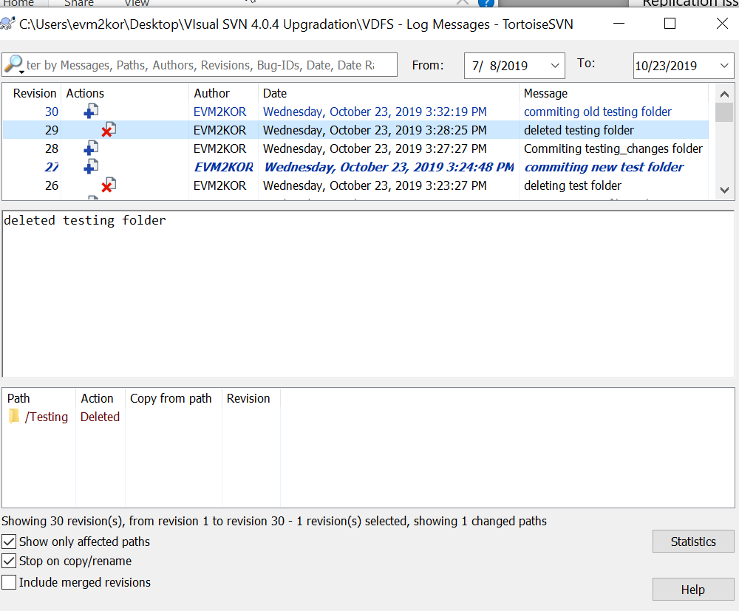

Step3: Give a right click on the deleted log here you will get many tabs choose the Revert changes from this revision

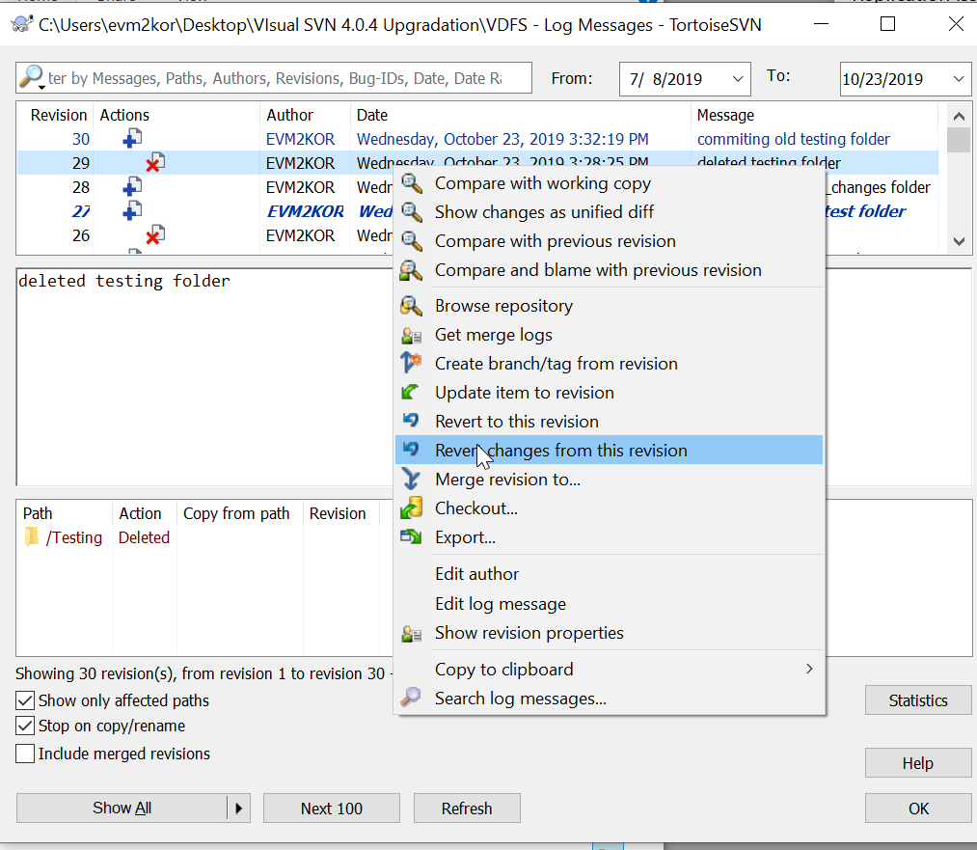

Step4: Click on Revert, Now whatever you have deleted everything will be reverted here

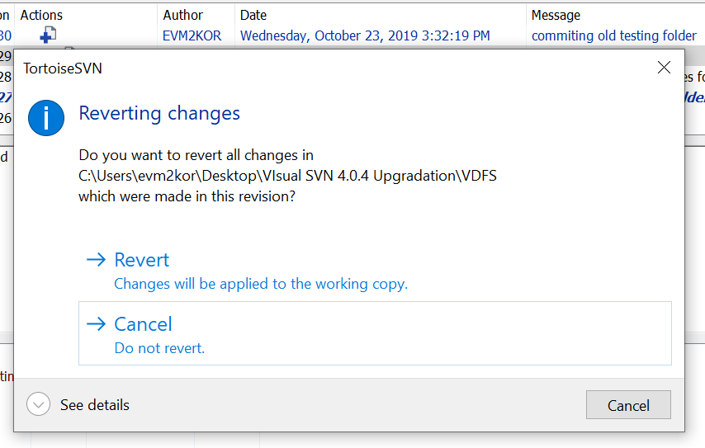

Step: Finally commit all the changes to the repository.

Note: These procedure won’t work if we delete the project folder directly from the server